Part One: Gaps Identified
The most significant gap identified by the team is the limited analytical depth of the reports. Throughout the project, the team repeatedly observed that the reports present only the “what”, and even that in limited detail. Researchers and investors, however, also need figures that explain the “why”, such as the drivers behind changes in users, transaction volumes, and values. For example, eFAWATEERcom’s total transaction value fell by 12.0% in Q1 2026, yet the report gives no indication of what drove the decline, such as a specific biller category or seasonal effect. Without this context, researchers cannot validate trends, and investors cannot assess whether growth is sustainable. As a result, readers must rely on assumptions to interpret changes, which increases the risk of misleading conclusions. The reports are consistent and well structured, and they provide a reliable record of what happened in each quarter. The recommendations below address this gap using only data already available in JoPACC’s dataset.

Part Two: Notes and Recommendations

Interactive UI
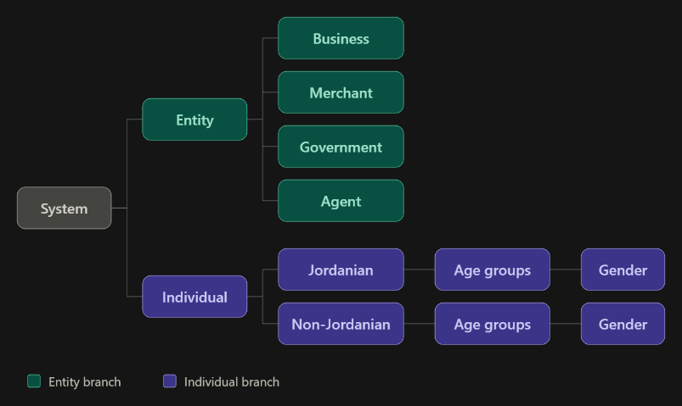
To apply this hierarchy to the IPS, the IPS section of the report would be restructured around it. Figures from CliQ and JoMoPay would be combined under one shared structure: users and transactions would first be split into entities (business, merchant, government, agent) and individuals, then individuals by nationality, age group, and gender. For each level, the report would show the number of users, the number of transactions, and the transaction value, using only data already published in JoPACC’s dataset. The same structure could then power an interactive view, allowing readers to drill down from the system total to the most detailed breakdown. Categories with very small counts would be grouped to protect confidentiality.

This recommendation is presented first because the others build upon it. The remaining recommendations can be implemented without an interactive interface, but interactivity would greatly extend what the reports can offer. It would allow researchers, investors, and other readers to explore the data at the level of detail they need, so the reports can serve a wider range of users.

New Trend Analysis Metrics
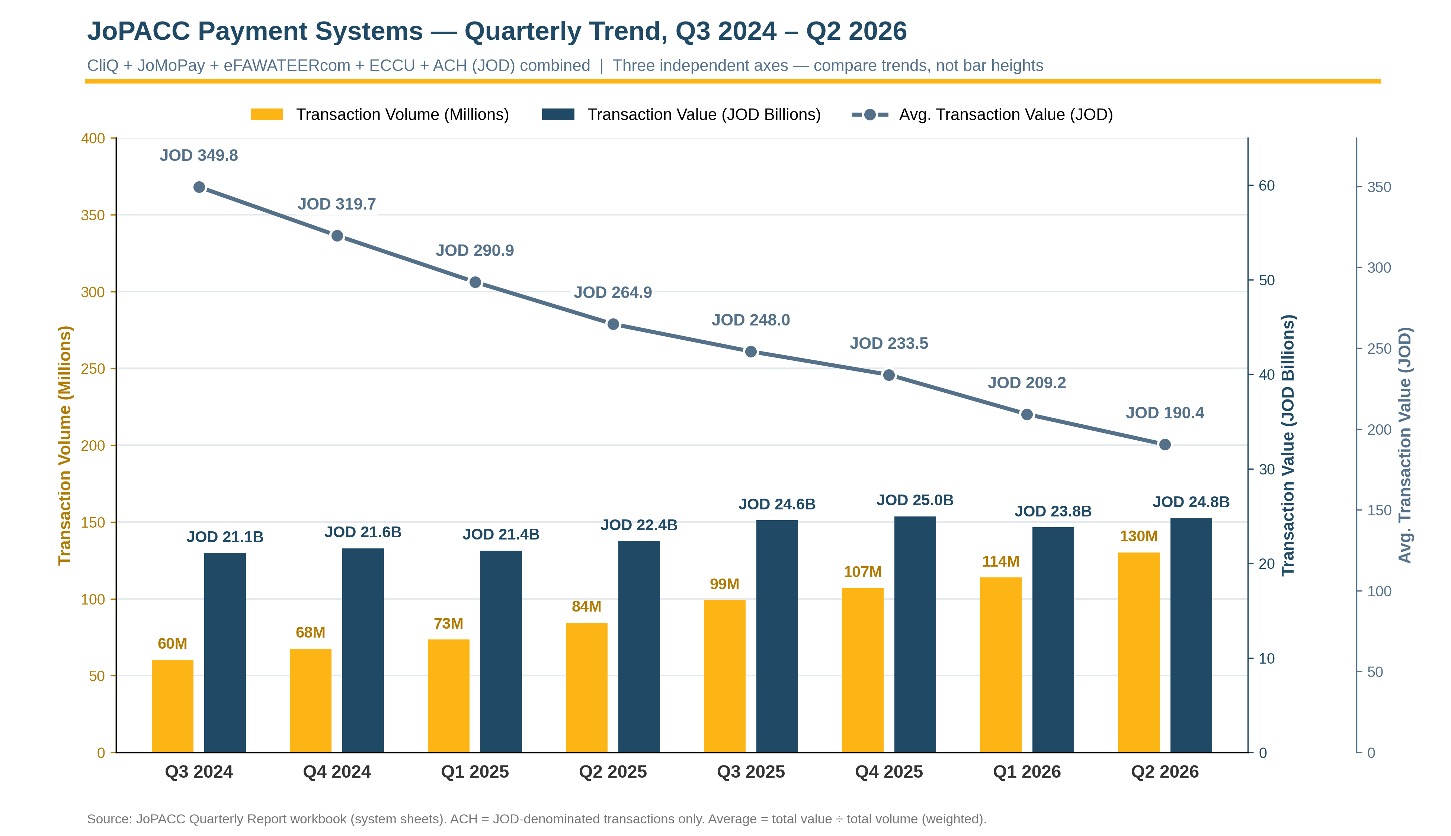
A review of the trends in the quarterly reports showed that the most notable movement occurred in the third quarter of 2025, when the number of transactions was low relative to the value of transactions. This led to a manual calculation of the average transaction value for each quarter, and for each month of the quarters that followed. It is recommended that average transaction value be added to the reports as a standard metric, as it would support deeper research and analysis.

Combining the systems into a single trend view shows that payment volume grew from about 60 million to 130 million transactions per quarter between Q3 2024 and Q2 2026, while total value rose by a much smaller margin, from JOD 21.1 billion to JOD 24.8 billion. As a result, the average transaction value fell by roughly 45%, from JOD 349.8 to JOD 190.4. This indicates that growth is driven by a larger number of smaller payments rather than by higher-value transactions, a pattern that the totals alone do not reveal. Publishing the average transaction value would help researchers and investors interpret growth correctly, and would help operations and risk teams plan capacity and set monitoring thresholds. The average is not a fully accurate measure of the typical transaction, however. It is calculated as total value divided by total volume, so a small number of very large transactions can raise it significantly. Measures such as the mode (the most frequently occurring transaction value) or the median (the middle value) would better represent a standard transaction. These could not be calculated from the published reports, which do not include individual transaction values or their distribution, so the average is the best indicator that the available data allows. Publishing such measures, or a distribution of transactions by value range, would be a valuable future improvement. Because the average also combines systems with very different transaction sizes, it should be reported for each system, so that readers can tell genuine changes in transaction size from shifts in the mix of systems.

